Quiz time – chose either, English, maths, geography, history or science. Write three questions on your chosen subject.
Meerkats and Zebras. We miss you!
We thought that we would try a different approach to your home schooling. You will still be learning the key skills you need in English and Maths but in a different, creative way. Let us know what you think by sending us in photographs or notes giving us your thoughts and opinions.
Parents, could you please also let us know if you have access to a printer by dropping us an email. None of the work below requires any printing, you will just pen and paper. If you need any help or advice at all please email us any time.

This will then be collated and sent back out for you to answer everyone’s questions.

Become a News reader – make the news about something you have done at home. It could be a game you have played, a cake you made or even that the food shortage is over in your house as mum has been to the shops! Record these and send them in! Remember all news readers dress for the television – so put on your best clothes! You could:
Make recordings on your daily walk, ask family members to send over an interview, include a weather report, film a sporting challenge that you could do in your home or garden, (football, gymnastics) you may want to include a musical section of the news report.

Get rhyming – Write a song, rap or poem about being in lockdown. Has your dad shaved his head? Is mums hair turning grey? Has your little brother or sister done something funny? Write about the funny things that are happening.

Master Chef – You are now the proud owner of your very own flash restaurant! I am so proud!
Your task is to plan a menu, you might want to include; starters, main and desert.
Costing is vital parts of being an entrepreneur therefore you need to include the price of each ingredient you use in your menu. Weigh each ingredient out carefully to avoid waste.
You could cook anything you like it could be as easy as spaghetti bolognaise (my favourite!) or as adventurous as lobster thermidor! If you are really good at your job when you serve your family you may even get a tip.

Science Boffins-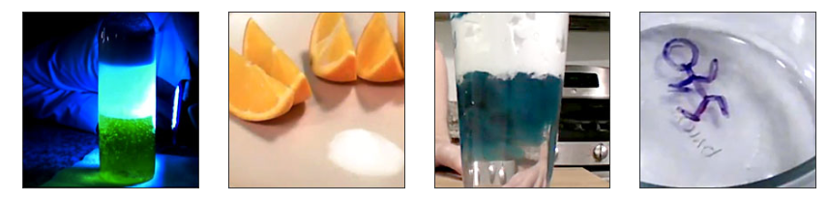Become a scientific investigator! Have a look at this website and try some amazing science investigations at home. http://www.sciencefun.org/kidszone/experiments/ If you don’t have any of the equipment needed for these experiments, then you could find out about; space exploration, under the ocean or the environment.

Miss Scott is trying to get as many people as she can involved in a world record art lesson. The lesson will take place online on the 21st May at 4:00-4:30pm. It will be led by World Book Day author and childrens’ book illustrator, Rob Biddulph (#DrawWithRob). The lesson is free to join and suitable for everyone at home. To beat the Guinness World Record title they need more than 10,000 people to tune into Rob's lesson, so please try and spread the word. All you need to do is register at https://www.artworldrecords.com/ and tune in on the day.
If you would like to register then please do, and send us a copy of what you draw.

