Week 1 | Monday | Tuesday | Wednesday | Thursday | Friday
AM | Maths  Read or listen to the story ‘Superworm’ By Julia Donaldson  https://www.youtube.com/watch?v=7Jnk3XApKBg  Over the past few weeks we have learned a lot about minibeasts. Can you continue our patterns and then make your own.  (See image attached below).  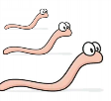  Can you make your own mini beast patterns? Take this further by using different sizes of the minibeasts! For example, length or size of your superworms!  Literacy  Look at a worm (picture attached below)  How could you describe the worm? Can you write down as many words as you can to describe the worm. (e.g. slimy, wiggly, pink)  But this is no ordinary worm, this worm is a Superworm! But when people look at him they don’t think of super words to describe him, they use boring words instead. Can you think of any new words to add to your list to make him sound more exciting and interesting to other people? | Maths  Worm number lines! Superworm is super Long! But how long is he? Let’s look closely at worms! Let’s draw worms like in “I can only draw worms.”  We can see the worms he draws look a bit like our number lines at school! Draw your worms but start at different numbers! (An example is attached below).  Now try your worms counting back! (An example has been attached below).  Literacy  Using the words you thought of yesterday, can you put these words into a sentence? For example, ‘Superworm is..’.  Can you add a conjunction to your sentence?  Once you have written 2 to 3 sentences, draw a picture of your amazing worm! | Maths  Superworm has many abilities and many moves. How many super moves can you do in 1 minute?  Superworm the skipping rope. How many skips can you do in 1 minute? Can a grown up time you? Check your counting! How else can you move your body like Superworm. Can you hula hoop for 1 minute? Can you use your body as a swing – swing your arms? Can you count 20 of one move and count it?  Literacy  Re-Read or listen to the story ‘Superworm’ By Julia Donaldson  https://www.youtube.com/watch?v=7Jnk3XApKBg  In the story Superworm goes missing! Can you create a wanted poster to display for people to see to help find Superworm. What information will you need to include on your poster? | Maths  Create your own yucky supermarket by labelling tins of mini beasts! Who will be in yours and how many?  Pick your tin! Look at the different sizes of these cylinders! Look at making labels and think about the amount that will be in that tin! If you draw around the old label then you can get the exact size. Pick your minibeast contents. Are there going to be just one minibeast in a can? Make labels as fancy as you want! (Grown ups you might want to mark the tin with what is really in it!)  Then go shopping and combine your tins of yuck! How many minibeasts would I have if I had a tin of my caterpillars and a tin of slugs? What about half a tin of worms and a tin of slugs? Look at different combinations. (An example is attached below).  If you want to take this further you could price up the tins and make a yucky shopping list! Go shopping with a budget! How much is a tin of spiders? How much would 3 tins be? Are caterpillars expensive? How much? Look at the money in your piggy bank, what could you buy with your pennies?  Literacy  Can you think of some questions that you might like to ask Superworm? How might he respond? Once you have thought of some questions, use your phonics to write them down. | Maths  Get together your own collection of worms and see if you can cut them to different lengths. Talk about the lengths and even measure with a ruler or tape measure.  Of course we are not going to cut real worms! Grown ups cook some spaghetti until almost cooked and then rinse under cold water. You can add food colouring to make them any colour you want if you want fancy worms! You now have ready made worms to cut. (You can use string, dough or wool if you don’t have spaghetti.) Can you order them in length? What is your longest worm as long as in your house? What is your shortest worm as long as?  Singing time! We know a song describing worms! A fun way to remember the terms of length and size and ordinal numbers! (See attachment below).  Literacy  Can you make your own story about a different animal that becomes a superhero?
PM | Use your “Superworm” skills to make symmetrical art works. Explore what length your worm needs to be to make more complex patterns and the effects he makes!  Spoiler alert… we will not use real worms! You will need: Paper, paint in different colours and some string/wool.  - Fold your paper in half to see the middle line. Open it back up.  - Cut your lengths of string to different lengths – making sure there is enough for you to keep hold of it when in between the paper.  - Take a piece of string, dunk it in the paint leaving an end free of paint to hold on to.  - Next lay the paint covered string on one side of the folded paper in any pattern, leaving the clean end of the string out.  - Then fold the paper back together and put your hand on the paper so you can feel the string through the paper and begin pulling the string out moving it around the edges of the paper. It’s really fun to have more than one string with different colours.  - Pull the strings out and open up the paper and ta da! A super creation! | Make your own fridge magnet worm. All you need is a peg, some small pompoms or polystrene balls, glue, googly eyes and a small magnet.  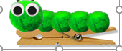  - Glue the pompoms or polystyrene balls to the peg. (Save the largest one for the head)  - Glue the eyes onto the head. If you don’t have googly eyes thenyou could draw some eyes on paper and cut them out.  - Stick the small magnet to the back of the peg.  - Leave to dry for a little while and then pop on your fridge.  You could use it to hold one of your lovely pictures, | Worms come to the surface when they hear the rain on the ground. Sometimes noises convince them it is raining and to come up. Can you make up your own rain dance to make the worms appear?  Some cultures do dances to make it rain as well! You can look these up on the internet to get some ideas. Could you put your dance to music? Or use your favourite tune? Think about noisy moves like rain to get those worms to show themselves!  Worm Rain Dance  10 stamps - one foot 10 stamps - other foot 6 claps 5 bunny hops 2 spins 4 times shout “RAIN” | Make a worm coming out of an apple. You will need a paper plate, some red paint, dome green card or paper, scissors and glue.  - Paint your paper plate red and leave to dry.  - Cut out your leaves and your worm from the green card. Give your worm some stripes and a smiley face.  - Add your leaves to the top of your paper plate and cut a small hole just below half way to the right.  - Thread your worm through and see how he has ate his way through the apple.  You could hang your plate on your worm fridge magnet, | Why not make your own worm farm. Use the link below.  https://www.persil.com/uk/dirt-is-good/games/how-to-make-a-worm-farm-for-kids.html  Take some photos of your worm farm and send them to us.

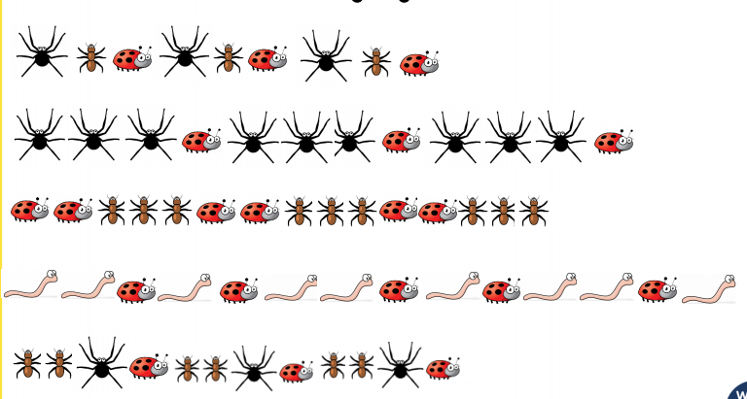
Monday

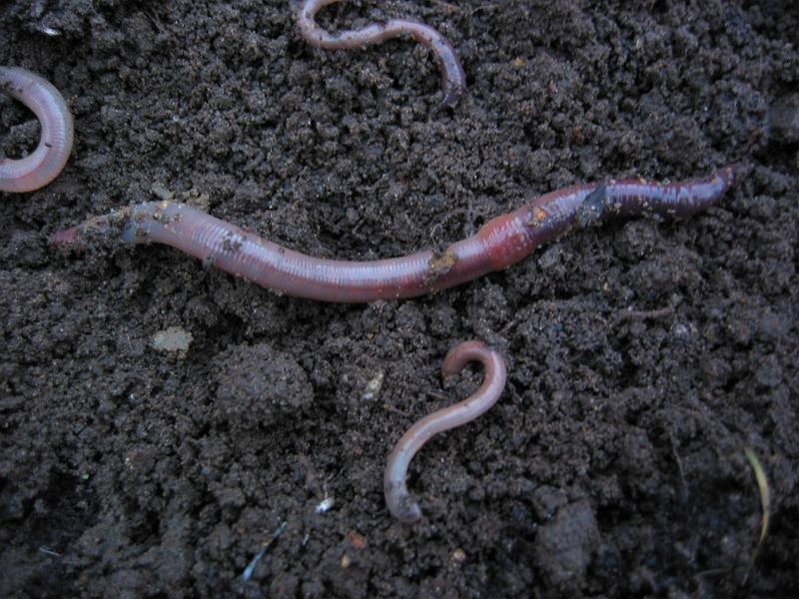

Tuesday - example
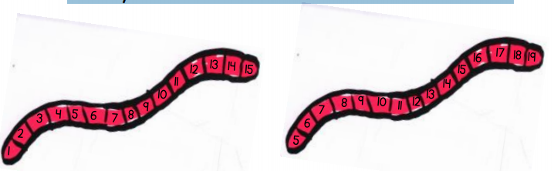

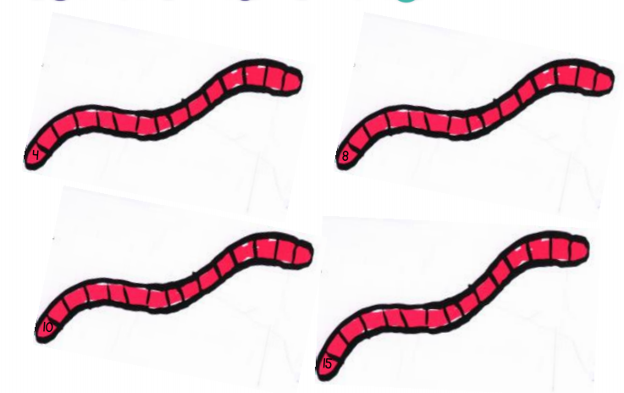

Your turn!

Your turn!
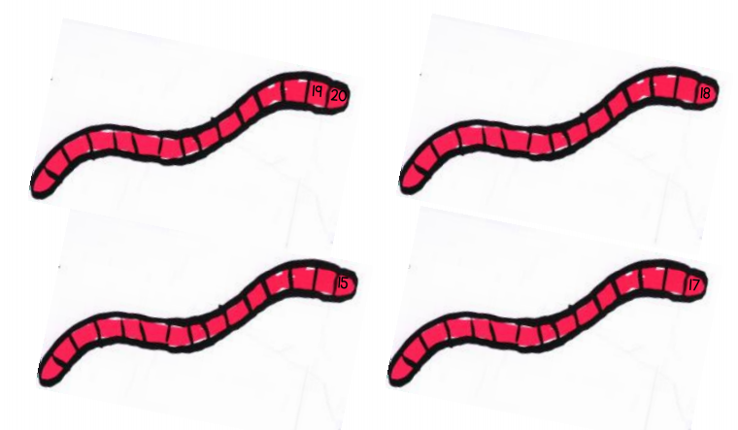

Thursday
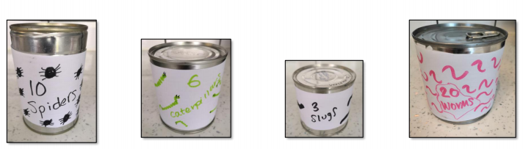

Friday
